Project Develpoment Phase
Date | 9 July 2026
Team ID
Project Name | India's Agricultural Crop Production Analysis
Maximum Marks | 4 Marks
Data Preprocessing Steps
Step 1: Import the Dataset
- Imported the Agricultural Crop Production dataset into Tableau Public.
- Verified that all records and fields (State, District, Crop, Year, Season, Area, Production, and Yield) were imported successfully.
- Confirmed that the dataset was ready for preprocessing.

Step 2: Check for Missing Values
- Examined the dataset for null or blank values.
- Verified that important fields such as State, District, Crop, Season, Area, Production, and Yield contained valid information.
- Missing values were handled appropriately to ensure accurate analysis.

Step 3: Remove Duplicate Records
- Checked the dataset for duplicate records.
- Removed duplicate entries to avoid incorrect analysis and visualization.
- Ensured that each agricultural record was represented only once.

Step 4: Validate Data Types
Ensured that each attribute had the correct data type.
- State → String
- District → String
- Crop → String
- Year → Number
- Season → Categorical
- Area → Number
- Production → Number
- Yield → Number

Step 5: Verify Data Consistency
- Checked for invalid or unrealistic values such as negative production, area, or yield.
- Standardized state names, district names, crop names, and season values.
- Ensured consistency across all categorical fields before visualization.

Step 6: Prepare Calculated Fields
Created calculated fields required for dashboard analysis, including:
- Total Production
- Average Yield
- Total Cultivated Area
- Production by State
- Production by Crop
- Production by Season
- Year-wise Production Trend
- KPI Measures for Dashboard

Step 7: Final Clean Dataset
- Verified that the cleaned dataset was complete and suitable for analysis.
- Confirmed that all preprocessing activities were completed successfully.
- The dataset was finalized for dashboard creation and interactive visualizations in Tableau Public.

Business Questions with Visualization
S.No. | Business Question | Visualization
1 | How many agricultural crop production records are available for analysis after data preprocessing? | Total Records(KPI Card)
2 | What is the total agricultural production across all states? | Total Production (KPI Card)
3 | Which crop has the highest production? | Crop-wise Production Analysis
4 | How does crop production vary across different states? | State-wise Production Analysis
5 | Which districts contribute the highest agricultural production? | District-wise Production Analysis
6 | How does agricultural production vary across different seasons? | Season-wise Production Analysis
7 | How has crop production changed over the years? | Year-wise Production Trend
8 | What is the average crop yield across different crops and states? | Yield Analysis (KPI & Charts)
3. Visualiztions:
Total Yield


Total Production



Total Production Chart

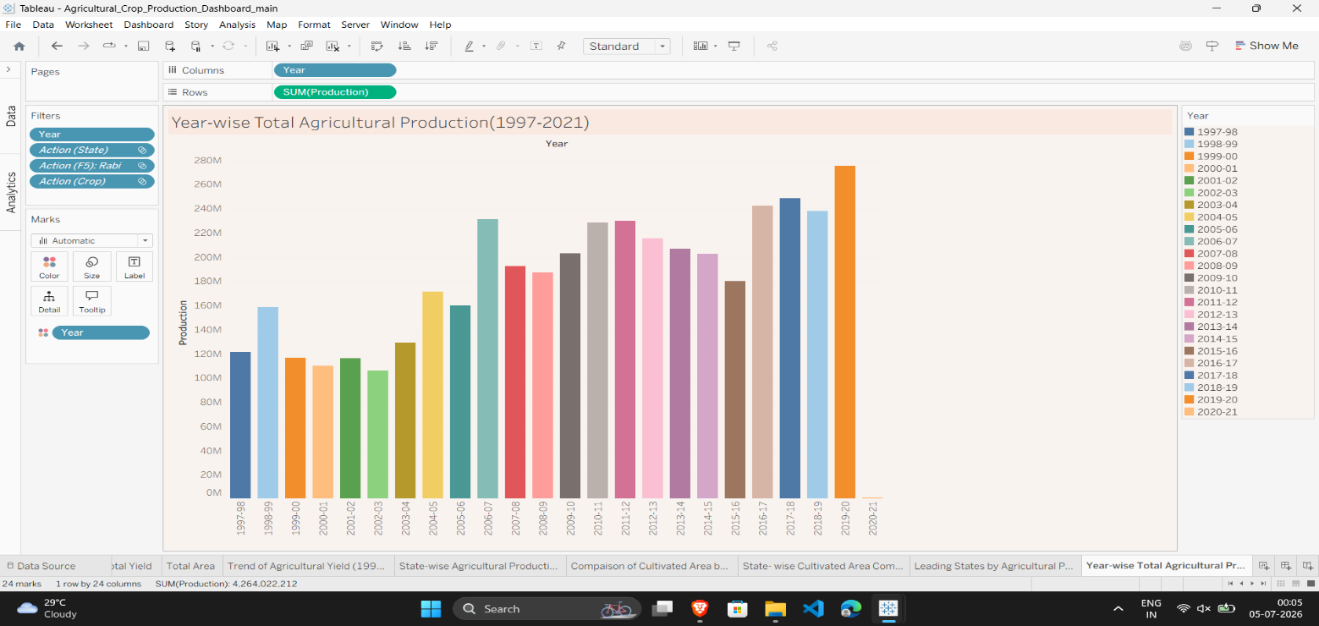

Production by Unit Type
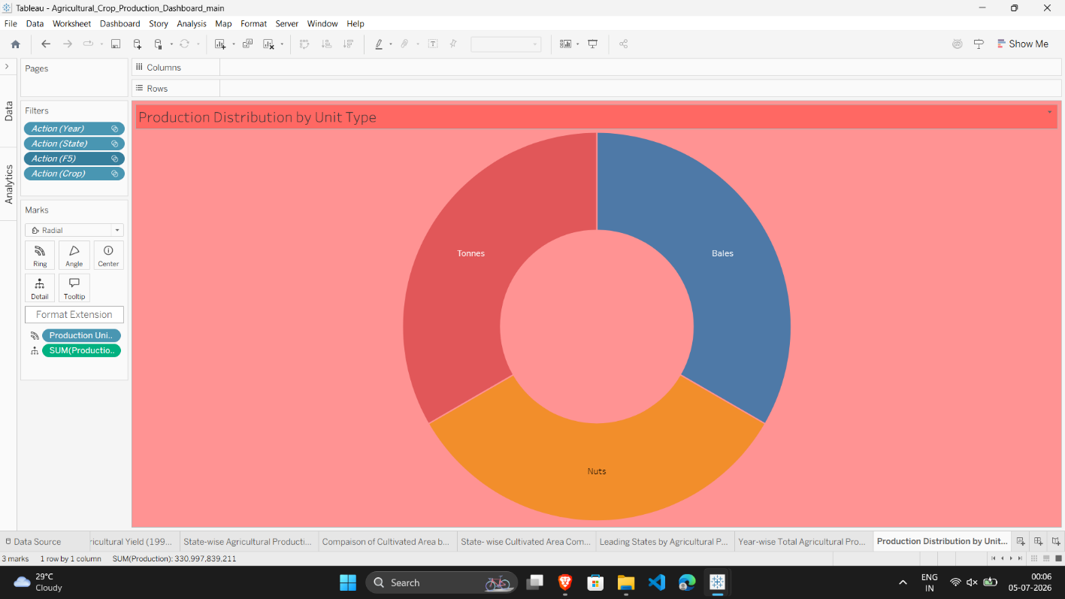
Trend of Agriculture

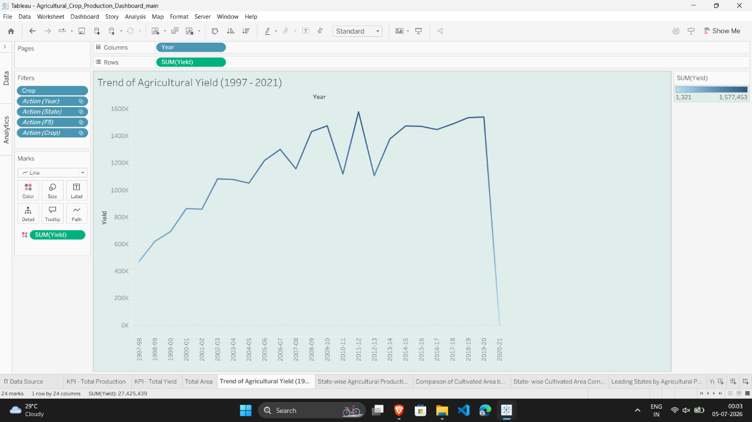
State wise
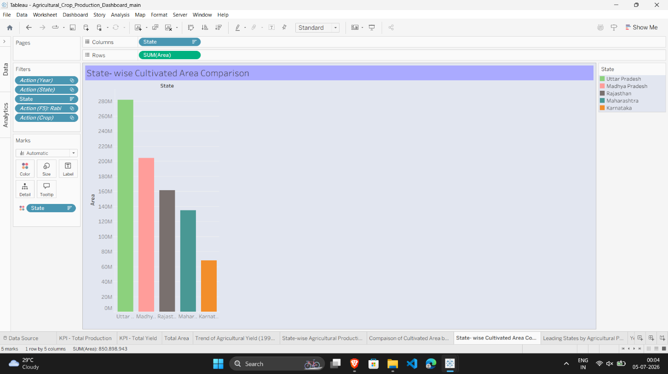

Dashboard



